MAG
Ticket Printer
BOCA SYSTEMS, INC.
© 2000 Boca Systems, Inc. All rights reserved.
Under the copyright laws, this manual may not be copied, in whole or in part, without the written consent of BOCA.

Every effort has been made to ensure that the information in this manual is accurate. BOCA is not responsible for printing or clerical errors and reserves the right to change specifications without notice.
Table of Contents Page
1.0 | Introduction | 1
2.0 | Unpacking the Printer | 2
3.0 | A tour of your printer | 3-5
4.0 | Installation | 6
5.0 | Configuration | 7
6.0. | Standard Interface Pinouts | 8
7.0 | Thermal Paper - Theory and Specification | 9
8.0 | Maintenance and Adjustments | 10-15
9.0 | Magnetic Encoding - Theory and Specifications | 16-19
10.0 | Spare Parts | 20
11.0 | Troubleshooting Guide | 21-22

Table of Figures and Appendices Page
Figure 1 | Packaging | 2
Figure 2 | Mag 42 Ticket Printer | 3
Figure 3a | Mag 42 side view | 4
Figure 3b | Mag 42 side view - Electronics Exposed | 4
Figure 4 | Rear view | 5
Figure 5 | Ticket loading | 6
Figure 6 | Switches and Optical Devices | 11
Figure 7 | Print head removal | 13
Appendix A | Operator Menu options through control panel

FCC NOTICE

IMPORTANT NOTICE
THE PRINTER MUST BE OPERATED WITH THE COVER ON AND ALL SCREWS ATTACHED. THE DATA CABLE MUST BE SHIELDED.

FAILURE TO OPERATE IN THIS MODE MAY CAUSE THE PRINTER TO EMIT EMISSIONS IN EXCESS OF EITHER FCC OR CE REGULATIONS. ADDITIONALLY, THE PRINTER MAY BECOME SUBJECT TO DAMAGE BY EXCESSIVE ELECTROSTATIC DISCHARGES IF NOT OPERATED IN THIS MANNER.
i
NOTE: The equipment has been tested and found to comply with the limits for a class A digital device, pursuant to part 15 of the FCC rules. These limits are designed to provide reasonable protection against harmful interference when the equipment is operated in a commercial environment. This equipment generates, uses, and can radiate radio frequency energy and , if not installed and used in accordance with the instruction manual, may cause harmful interference to radio communications. Operation of this equipment in a residential area is likely to cause harmful interference in which case the user will be required to correct the interference at his own expense.

Operation is subject to the following two conditions:
1. This device may not cause harmful interference, and
2. This device must accept any interference received, including interference that may cause undesired operation.

NOTE: This unit was tested with shielded cables on the peripheral devices. Shielded cables must be used with the unit to insure compliance.
WARRANTY INFORMATION
ii
PRINTERS - BOCA warrants each printer to be free of defects for a period of one year from the date of shipment when subject to normal use and service. This warranty covers all parts and labor except for the print head which is warranted for 90 days. All warranty labor is to be performed at the BOCA facility. Equipment damaged by misuse or negligence including damage to print heads caused by defective ticket stock is excluded from this warranty.

Any defective equipment meeting these conditions should be returned to BOCA for repair (freight prepaid) in its original box and packing material. A short note describing the failure should be enclosed with the printer.
Equipment damaged in shipping should be reported immediately both to BOCA and to the shipper.
EXTENDED WARRANTY PLAN - BOCA offers extended warranty plans for all printer models. These plans cover all parts and labor. All labor is to be performed at the BOCA facility. Equipment damaged by misuse or negligence including damage to print heads caused by defective ticket stock is excluded from this extended warranty. The customer, at his option, may request BOCA to ship individual parts to expedite simple repair procedures. In certain cases where the customer is unable to wait for the normal repair cycle, BOCA will ship an exchange printer within one business day after notification by the customer. All freight charges are the responsibility of the customer.
1.0 Introduction
The BOCA Mag 42 is a direct thermal ticket printer with read-write magnetic capablility and integrated bursting mechanism designed for ticketing environments which require encoding and verification of data on a magnetic stripe. The printer is available in a credit card (ISO 3 track) version. This manual will provide the user with general information regarding printer set-up, configuration and troubleshooting. Please review your programming guide for additional details.

2.0 Unpacking the Printer
The printer is shipped in a ruggedized container. Please save packing material for future use. Remove the printer (see figure 1) and accessories from the box and inspect for obvious damage. If damage is noticed, please report it immediately to BOCA.
Tel: (561) 998-9600 Fax: (561) 998-9609 E-mail: bocatix@bocasystems.com

The following items should be in the box: a) Ticket Printer b) Hopper
c) AC power cord
d) Interface cable (optional)
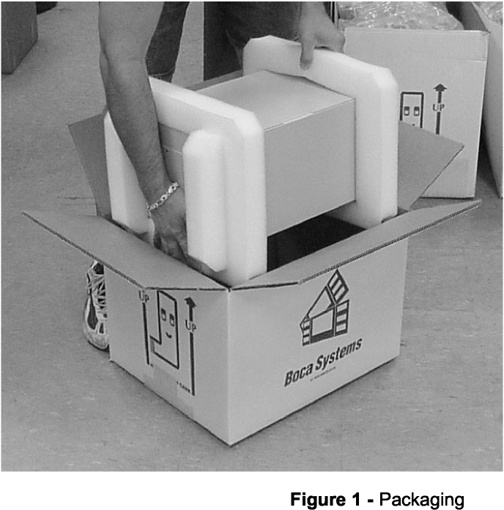
3.0 A Tour of Your Printer
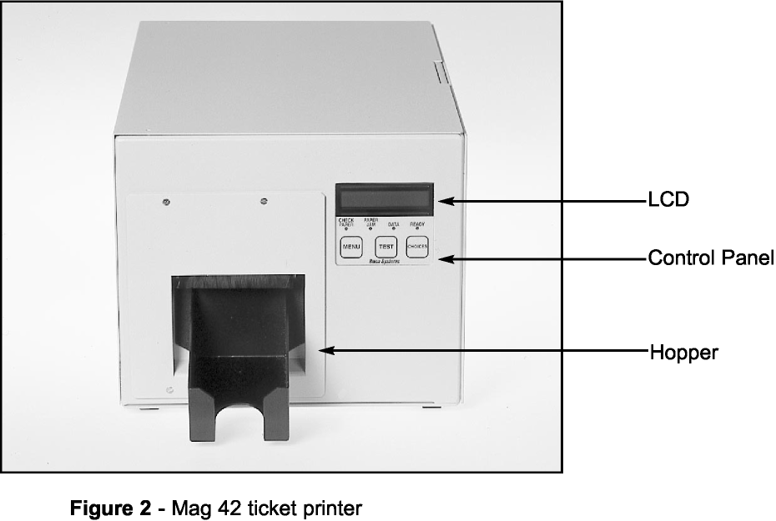

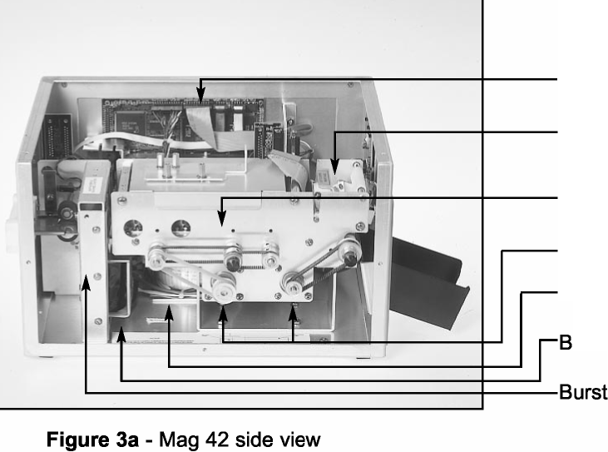
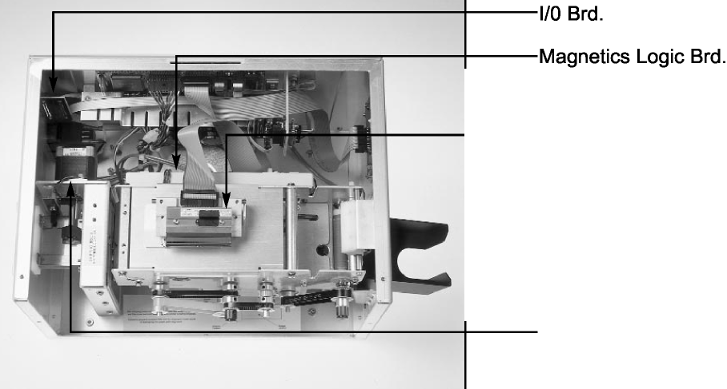
Logic Board
Print Head Magnetics Module
(obscured)
Stepper Motor (2)
Toroid Transformer Board
urster Solenoid er Assembly
Infeed Stepper Motor

Figure 3b - Mag 42 top view
Print Head Removed

4.0 Installation

6
INSTALLATION:

1. Place the printer onto a counter top or shelf.

2. Confirm that the line voltage agrees with the voltage listed on the label affixed to the rear of the printer.

3. Attach the AC cord and interface cable into the proper connections located on the rear of the printer.

4. Turn power on using the switch located above the power cord connection on the rear of the printer.

LOADING TICKET STOCK:

1. Verify that the CHECK PAPER light is lighted and PAPER OUT is displayed on the LCD display.

2. If necessary, remove the last ticket of the previous load from the input bezel.

Note:
When the last ticket is sensed at the input bezel, the printer will indicate out of paper. The last ticket, which will be protruding from the rear of the printer, must manually be removed from the input bezel prior to loading more stock.

3. Locate ticket stock into position behind the printer.

Note:
Ticket orientation should be with the magstripe facing up and on the inboard (away from the door latch) side of the printer.

4. Place the first ticket into the input bezel and slide forward until it engages the input roller.
5. Press the TEST button and the ticket stock will automatically load to the proper position.
6. Verify that the READY light is lighted.
7. Press the TEST button again and the printer will print a test ticket.
8. The printer is now ready for normal operation.

Note:
To remove ticket stock from the printer after it has been properly loaded, pull the ticket stock out from the input bezel and press the test button to clear the ticket path.
5.0 Configuration
The Mag 42 is factory configured for 300 dpi. An optional Windows compatible
(HP emulation) is also available. The printer is factory configured for either serial, USB or parallel interface (see pinouts in section 6.0).

A number of other features including baud rate, burst count and print speed are also factory set but can be modified (Operator Menu) through the touch panel as described in Appendix A. Most users will never have reason to change the options in the Operator Menu.

6.0 Standard Interface Pinouts

8
6.1 Serial Pinouts
RS232 (Standard) |  | RS232 (PC type)
Pin | Function | Pin | Function
2 | Printer Transmit | 2 | Printer Receive
3 | Printer Receive | 3 | Printer Transmit
7 | Ground | 5 | RTS (+5Vdc)
5,20 | DTR (Printer Ready) | 6 | DTR (Printer Ready)
4,22 | RTS (+5Vdc) | 7 | Ground
 |  | 8 | CD (+5Vdc)
6.2 Typical RS232 Pin Connections
(Standard)  25 PIN PC |  | (Standard)  9 PIN PC |  | (PC Type)  25 PIN PC |  |  | (PC Type)  9 PIN PC
BOCA | CPU | BOCA | CPU | BOCA | CPU | BOCA | CPU
2 | 3 RXD | 2 | 2 RXD | 2 | 2 TXD | 2 | 3 TXD
3 | 3 TXD | 3 | 3 TXD | 3 | 3 RXD | 3 | 2 RXD
7 | 7 GND | 7 | 5 GND | 5 | 5 CTS* | 5 | 8 CTS*
20 | 6 DSR | 20 | 6 DSR | 6 | 6 DSR | 6 | 6 DSR
20 | 5 CTS* | 20 | 1 CD* | 7 | 7 GND | 7 | 5 GND
20 | 8 CD* | 20 | 8 CTS* | 8 | 8 CD* | 8 | 1 CD*
* Optional Connection
6.3 Parallel Pinout
Pin Function
1 Strobe (negative)
2-9 Data (DB0-BD7)
10 ACK (negative)
11 BUSY
12 PAPER OUT
15 ERROR (negative)
18 Ground
NOTE: The above pinouts may vary on certain printers due to special customer request.
7.0 Thermal Paper - Theory & Specification

9
The print head’s life expectancy is composed of both a mechanical and an electrical component. Both of these factors are strongly influenced by the quality of the thermal paper used.

MECHANICAL
The print head has a theoretical rating of 60 kilometers. This number is based upon the assumption that the head will be used with a good quality, top coated thermal paper. Uncoated and poorly top coated thermal papers are abrasive to the print head and have been found to wear through the head after less than one kilometer. Although top coated papers significantly improve the print head life, we strongly advise covering the entire front surface of the ticket with transparent white thermal ink to supplement the top coating.

Other factors which may contribute to premature mechanical wear are the use of non-thermal inks and stray metallic particles stuck in ticket perforations. Certain inks colors such as opaque white (which contains titanium dioxide) are also highly abrasive.

Unfortunately, there are no available devices for quantitatively measuring the abrasiveness of a given ticket. Fortunately, we have developed a slightly subjective, but effective method of weeding out overly abrasive ticket stock.

ELECTRICAL
Each heat element, dot, on the print head has a theoretical life expectancy of 100 million activations. This is based on the assumption that each activation will cause the dot temperature to approach the dot’s maximum recommended temperature. Running at lower temperatures will increase the theoretical life expectancy, while slight temperature increases will seriously (exponentially) degrade the head life.

The thermal paper can affect the electrical head life in two ways. Insensitive, slow to image papers, will typically encourage the user to increase the voltage to darken the printed image. This will directly increase the head temperature resulting in reduced head life. Additionally, the higher temperatures will frequently cause the ink to peel off the ticket and deposit onto the print head. The ink debris will disrupt the normal transfer of heat from the head to the paper. This further increases the head temperature above the desired level. The use of non-thermal inks and/or non-top coated papers also will cause the ink to release and deposit on the print head.

SPECIFICATION
Based upon the above technical information, BOCA has always tried to encourage our customers to use the proper thermal papers to maximize the life of their print heads. BOCA provides an extensive series of papers which meet the above criteria for low abrasion and high sensitivity. We have also tested and approved a number of Ricoh thermal papers which meet our criteria. While we have not had the opportunity to test other manufacturers’ thermal papers, we feel confident that other papers manufactured with the above goals in mind should be acceptable for use in our printers. The following list of papers have been approved by BOCA.

200 dpi usage
BOCA T7, T5

300 dpi usage
BOCA HS7, HS11

Please note that the 300 dpi papers may be used on 200 dpi printers. In fact, doing so will increase the electrical life of the head as this will allow the head to operate at a lower temperature. DO NOT use 300 dpi heads with 200 dpi paper.
8.0 Maintenance and Adjustments

10
Your ticket printer is solidly constructed and has been designed for high volume use. It requires minimal care to provide maximum service.

This section provides an overview of printer maintenance.

For discussion purposes, the printer consists of three major modules or assemblies:
- Paper guide magnetics and print head assembly
- Burster assembly
- Logic board assembly
As a safety precaution, all service to the printer should be done with power off and the AC cord unplugged from the printer.
8.1 Paper Guide Magnetics and Print Head Assembly
The principal function of this assembly is to guide the ticket stock through the magnetics write head and read head and to the thermal print head where thermal printing takes place. If necessary, the total assembly can be removed from the unit. However, all replacements and adjustments of the components of this assembly can be done without removing the total assembly. The most common adjustments and replacements regarding this assembly follow:
8.1.6 THERMAL PRINT HEAD
The print head should be cleaned periodically to prevent debris from building up on the print element. The required cleaning interval varies greatly depending on the quality of the ticket stock and the amount of dust entering the print area. Excessive dirt build up on the print head will result in reduced quality. Continuing to run the print head in a dirty condition will reduce its life expectancy as it is unable to diffuse its heat properly.

The thermal print head can be removed for cleaning or replacement, as follows:
(Please refer to figures 9a - c)

1. Make sure power is off and the AC cord is disconnected from the printer.

2. DO NOT UNPLUG CABLE FROM PRINT HEAD.
3. Lift up on the cam lock assembly (located above the head mounting block) to remove pressure from the thermal head.
4. Lift up on the head mounting block/thermal head to remove.
5. Clean the thermal print head surface (the side that makes contact with the paper) with isopropyl alcohol.
6. Install the head by reversing the above procedures.
7. Restore pressure to the head by pushing down on the cam lock assembly.
8. The printer in now ready for operation. If the print quality is still poor then the thermal head needs to be replaced.
9. To replace the print head, remove the ribbon connector from the print head and then remove the print head from the mounting block by removing the two unmarked screws.
Figure 9A - Print Head removal

Unmarked screws (2)

8.1.7 Rubber Drive Roller (Platen)
The rubber drive roller should be cleaned once a year to prevent paper dust from building up on the roller. Clean drive roller with a paper towel and isopropyl alcohol.

1. Unlock the thermal head and tilt back to gain access to platen.
2. Clean the full length of the platen.
3. Rotate the platen clockwise and repeat step 2. Continue in the same manner for one full revolution of the platen.
4. Close or lock the thermal head. Printer is now ready for normal operation. (NOTE: The platen may require more frequent cleaning in dusty environments or when using inferior ticket stock.)
8.2 Burster Assembly
The Burster is a solenoid activated menchanism designed to separate the ticket at the perforation. The Burster requires no adjustments and is rated for approximately 750,000 cuts. Please be aware of the following:

The Burster should be blown out with air periodically to prevent debris from building up inside the cutter area. The required cleaning interval varies greatly depending on the quality of the ticket stock and the amount of paper dust entering the burst area.
8.3 Logic Board
The printed circuit board used in this product has been manufactured using surface mount technology. The printed circuit board cannot be effectively repaired in the field and should be returned to the manufacturer if repair is required.

8.4 General Cleaning
The interior of the printer should be cleaned whenever there is a visible accumulation of dust. Use a small vacuum for cleaning. Be careful not to jar any of the printer’s parts loose.
9.0 Magnetic Encoding
Theory and Specifications

Initialization Sequence
- The printer checks for a ticket at the encode position. If a ticket is present the printer goes ready.
• If a ticket is not at encode position, the printer checks to see if a ticket is at the load opto. If so, the ticket is moved forward to burst position, separated by the burster and moved to encode position.
Normal Operation
- The CPU sends magnetics data, followed by ticket data
- The printer starts the encode process
- The ticket moves through the print station and the next ticket is burst and moved to the pre-encode location
- The next ticket starts encoding
- The ticket is ejected after printing
Command Formats and Communications
- All printing related commands will be handled in accordance with BOCA’s FGL 42 programming guide.
- Any error in writing to the magnetic strip will cause the printer to automatically print a “void” ticket.
- To print a ticket without magnetics, just send a valid ticket with a print command. The printer will automatically bypass the encoding operation.
- All transmissions to and from magnetics will be as defined below. These functions will follow normal FGL formats.

CPU COMMANDS
COMMAND | Definition | Printer Response
<T1> | write track 1 magnetics
<T2> | write track 2 magnetics
<T3> | write track 3 magnetics
<T4> | write track 4 magnetics
<WM>  <bc#> | start writing magnetics  burst length | ACK or NAK after completion of encode & printing

Burst Count

16

The burst length is preset at the factory and should not require adjustment by the customer. In the event that the ticket is not bursting at the proper location, the burst length # should be adjusted to a value slightly greater than or less that the actual ticket length. The ticket length is defined as the number of dot columns in the ticket. (For example, a 3.375” long ticket at 305 dpi is approximately 1029 dots long.)

In addition to the burst length command, the burst count can also be adjusted from the front panel by entering the factory menu. The procedure for doing this is given below.

1) Press and hold the two control panel keys, (MENU & CHOICES) to enter the factory menu.

2) Scroll to the “INC BURST COUNT” or “DEC BURST COUNT” topic, depending on the direction of adjustment, by repeatedly pressing the MENU key.

3) Press the CHOICES key to select the topic’s numeric value.

4) Repeatedly press the CHOICES key to increment or decrement the value as necessary. Please note it is usually best to move in increments no larger than 10 counts at a time to prevent over compensation of the burst position.

5) Press the TEST key once to enter your choice and a second time to save the new value permanently and re-initialize the printer.
Magnetic Format

The magnetics section of the printer is shipped from the factory in ISO (1 thru 3 track) configuration.
ISO Format
The data for each track must be terminated with an EOT. All data must be sent in accordance with the ISO specification.

Typical ISO data stream

<T1> block1 EOT <T2> block1 EOT <T3> block1 EOT <WM>

NOTES:
1. Do not insert spaces in data stream. Spaces are for readability only.
2. ISO data contains only one block of data and no block separator characters.
3. A start, stop and LRC byte are automatically inserted into each track of data. These
three characters are counted among the maximum characters allowed per track.
4. Tracks 1 supports alphanumeric data. Tracks 2 & 3 are numeric only.
5. Maximum number of characters per track: Track 1 = 79; track 2 = 40; track 3 = 107
Automatic Re-print

Automatic Re-print is a user selected feature that provides for automatically reproducing a ticket, including the magnetics data that has failed the verification process. The printer will make up to three attempts to produce a good ticket from the original information before it returns an error message and halts any further ticket processing. This feature was designed specifically for those customers using parallel interfaces who can not receive status messages from the printer and would otherwise not know when a void ticket has been printed.

Automatic Re-print can be selected from the factory menu using the following procedure.

18

1) Press and hold the two control panel keys, (MENU & CHOICES) to enter the factory menu.

2) Scroll to the “Auto Reprint” topic by repeatedly pressing the MENU key.
3) Press the CHOICES key to select the topic’s options.

4) Repeatedly press the CHOICES key to scroll through the option list. Please note, the flashing black cursor indicates the current selection.

5) Select Yes to enable automatic re-print or No to disable it.

6) Press the TEST key once to enter your choice and a second time to save the new value permanently and re-initialize the printer.
10.0 Spare Parts

19
Please refer to the Boca Systems web site for a complete listing of Ghostwriter spare parts.
http://www.bocasystems.com
“Tech Support” Section
11.0 Troubleshooting Guide

20
This is a simplified troubleshooting guide listing some of the typical problems. It is not intended to provide technical details or repair methods, but can serve as a guide to fault isolation in the field. If you need additional help, please contact BOCA at
Tel: (561) 998-9600 Fax: (561) 998-9609
1. NO OPERATION, POWER INDICATOR IS OUT
a. Check the power cord for proper installation at both ends. b. Check main fuse and replace if blown. c. Check that there is power at the AC receptacle.
2. POWER IS ON BUT NO OPERATION
a. Check all electrical connections on the printer. b. Unplug the thermal head and turn on the printer.
If printer works, replace the thermal head. c. Replace the Main logic board.
3. POWER IS ON BUT TICKET WILL NOT LOAD
a. Check that the ticket stock is being loaded correctly. b. Replace ticket load opto. c. Replace the Main logic board.
4. ERRATIC CUT POSITION
a. Check for defective ticket stock Is the ticket too wide for the paper path?
b. Check that the platen is clean. Consult “Rubber Drive Roller” in Section 8.1.7. c. Replace ticket burst opto.
d. Replace the Main logic board.
5. ERRACTIC PRINT POSITION
a. See # 4
b. Replace ticket print position opto.
6. POOR PRINT OUT (light print out)
a. Make sure the print head/cam lock assembly is fully locked in the closed position. b. Clean print head. Consult “Thermal Print Head” in Section 8.1.6. c. Adjust print intensity setting via the control panel (see Appendix A) d. Verify quality of ticket stock
e. Replace thermal head.
7. POOR PRINT OUT (white voids in print out)
a. Clean print head. Consult “Thermal Print Head” in Section 8.1.6. b. Replace thermal head.
8. NO PRINT OUT
a. Check head cable for electrical connection at both ends
b. Check to make sure head cable is plugged in properly into the thermal head c. Replace the thermal head.
d. Replace the Main logic board.

The FGL 42 printers allow the user to adjust various printer options through the control panel.

MAG - Firmware ID
YY - Software Level
B - Major Revision Level # - Minor Revision Level
2. Enters new value / Also saves new values.
3. Scrolls through choices in individual menu topics. To access and use the OPERATOR MENU, follow these steps:

1. Ticket stock should be loaded into the printer. The LCD window displays MAG-YYB#

2. Press both MENU and TEST switches simultaneously for about three seconds. The LCD window displays OPERATOR MENU! .

3. To scroll through the menu topics, press MENU stopping on the topic you wish to change.

4. Press CHOICES to scroll through choices in the selected topic. NOTE: The printer displays a blinking cursor for the values presently stored in the printer.

5. Once you have found the new value you want, press TEST. The LCD window displays EXIT AND SAVE?. If you wish to save the new value, press TEST again.

6. If you do not wish to save the new value, press MENU. The LCD window displays JUST EXIT?. Press TEST to exit the OPERATOR MENU without saving new values or press MENU to enter back into the OPERATOR MENU.

Appendix A - Operator Menu Options

The chart below lists the present menu topics. These topics are subject to change.

1200,N,8,1 1200,E,7,1 2400,N,8,1 2400,E,7,1 4800,N,8,1 4800,E,7,1 9600,N,8,1 9600,E,7,1 19200,N,8,1 19200,E,7,1
OPERATOR MENU!
BAUD RATE?
PRINT SPEED?
DIAGNOSTIC MODE?
STATUS ENABLED?
PRINT INTENSITY?
TEST TICKET?
TICKET LENGTH?
INC BURST COUNT?
DEC BURST COUNT?
EXIT AND SAVE!
JUST EXIT?

The following is an overview of what each Menu option does:
BAUD RATE? Controls the serial interface baud rate, parity bit, data bits and stop bits.

Here are the Baud Rate choices:
(factory default)
PRINT SPEED?

LIGHT
MED LIGHT NORMAL MED DARK SHORT HEAD LIFE
Controls the speed the ticket travels at.
Also effects the print quality.
The numbers range from 0 - FASTEST to 7 - SLOWEST. 3 is factory default.

DIAGNOSTIC MODE?
Please consult your Programming Guide
Your choices are YES or NO. NO is factory default.

STATUS ENABLED?
Enables or disables the X-ON/X-OFF and status response protocols.
Your choices are YES (Enabled) or NO (Disabled). YES is factory default.

PRINT INTENSITY?
Controls the darkness of ticket print out. Here are the Print Intensity choices:
(factory default)
TEST TICKET?
Sets the format for a test ticket.
Standard
Configuration 1} Provides a printout of the printer
Configuration 2}
Configuration 3} configuration settings
Configuration 4}
Continuous Allows for continuous printing of test tickets
TICKET LENGTH?
3.375 - Credit Card size tickets 4.0 - Special 4” tickets
INC BURST COUNT?
Increments the steps required to position the ticket to burst position.
DEC BURST COUNT?
Decrements the steps required to position the ticket to burst position.
EXIT AND SAVE !
Will save any changes made to the above menu options.
If you wish to save the new value then press TEST, if not press MENU.

JUST EXIT?
Will exit the menu options without saving any changes.
If you with to exit without saving the new value then press TEST, if not press MENU.

