BCC MAG 42 - 46 Printer Cleaning Procedure

The feed opto and the paper path should be cleaned periodically to prevent erratic printer operation. Cleaning is normally done every three to four months. However, we recommend monthly cleaning for printers experiencing heavy ticket usage.

The cleaning procedure is as follows:

- Make sure power is off.

- Remove ticket stock from the printer.

- Remove the cover from the printer.
Roller sensor recess (2)
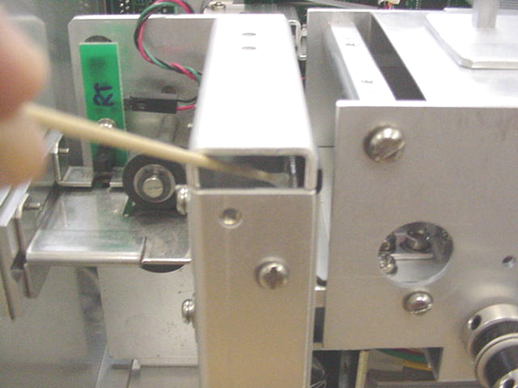
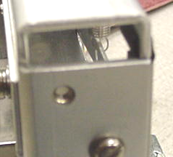
- Inspect the burster blade and clean it if a buildup of material is seen on the blade. Material buildup will mostly be found on the backside of the blade that faces where the tickets are loaded into the printer.
Using a 6” cotton tipped applicator and isopropyl alcohol gently clean the burster blade.
Burster Blade
- You will also want to clean the printer by vacuuming off any build up of paper dust that has accumulated inside the printer.
- Clean the ticket path by running the Boca Systems Magnetic Encoder Cleaner Strip (P/N P63-1000) through the printer as follows;
- Remove the cleaning strip from its package.
- Manually feed the strip through the printer by turning the drive belts counterclockwise (see photo A) and turning the drive pulley on the platen clockwise (see photo B).
- The strip may be turned over and run through the printer a second time.
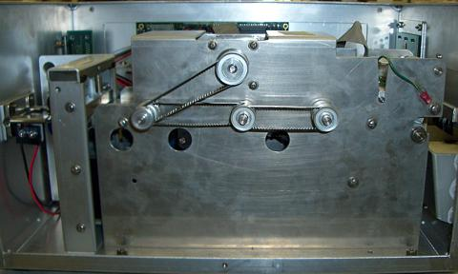
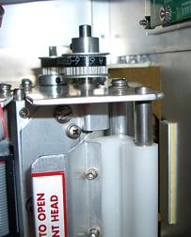

Photo A
Photo B

- The printer in now ready to resume normal operation.

Rev 05.01.07

