TCC MAG 42 - 46 Printer Cleaning Procedure

The feed opto and the paper path should be cleaned periodically to prevent erratic printer operation. Cleaning is normally done every three to four months. However, we recommend monthly cleaning for printers experiencing heavy ticket usage.

The cleaning procedure is as follows:

- Make sure power is off.

- Remove ticket stock from the printer.

- Remove the cover from the printer.

- Remove the paper path cover from the Magnetics Module.
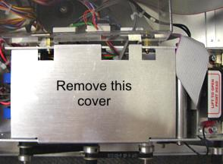

- Gently blow off the roller sensing recess area of the micro switches.

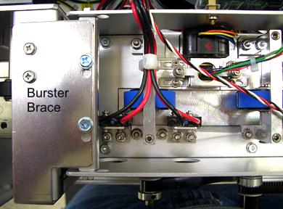
Roller sensor recess (2)

- Remove the burster brace mounting screws and burster brace from atop the burster assembly.
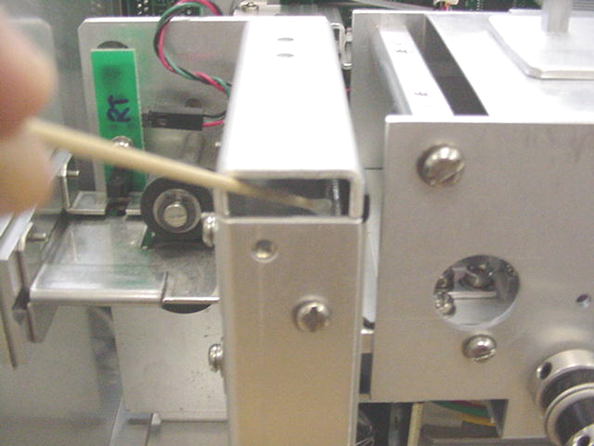
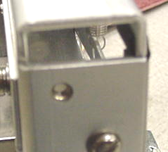
- Inspect the burster blade and clean it if a buildup of material is seen on the blade. Material buildup will mostly be found on the backside of the blade that faces where the tickets are loaded into the printer.
Using a 6” cotton tipped applicator and isopropyl alcohol gently clean the burster blade.
Burster Blade
- You will also want to clean the printer by vacuuming off any buildup of paper dust that has accumulated inside the printer.
- Clean the ticket path by running the Boca Systems Magnetic Encoder Cleaner Strip (P/N P63-1000) through the printer as follows;
- Remove the cleaning strip from its package.
- Manually feed the strip through the printer by turning the black knobs clockwise.
- The strip may be turned over and run through the printer a second time.
Black Knobs
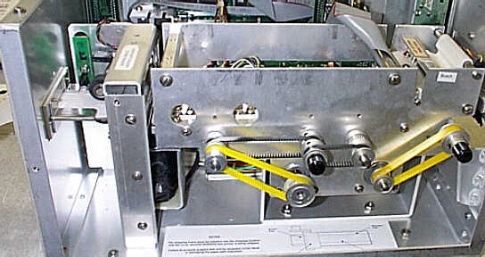

- You can skip this step if the rubber roller is clean. Apply a small amount of Isopropyl alcohol onto a paper towel to clean the rubber roller. Rub the paper towel across the roller to remove the debris. Continue in the same manner for one full revolution of the roller.
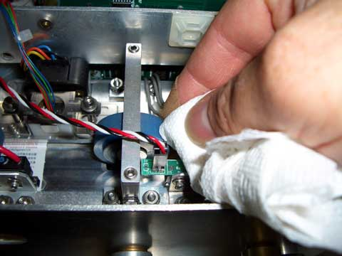

- Install the paper path cover back onto the Magnetic Module and the burster brace back onto the burster assembly.
- The printer in now ready to resume normal operation.

Rev 05.01.07

