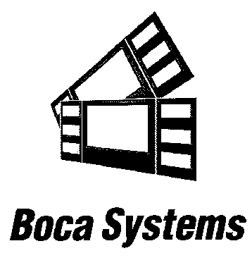

1065 South Rogers Circle • Boca Raton, FL 33487 • Phone (561) 998-9600 • Fax (561) 998-9609

Cleaning Procedure for Rubber Drive Roller (Platen)

The rubber drive roller should be cleaned once a year to prevent paper dust from building up on the roller. (NOTE: The platen may require more frequent cleaning in dusty environments or when using inferior ticket stock.)

1. Make sure power is off and the AC cord is disconnected from the printer
2. Unlock the cam lock lever and remove head mounting block/ plate. (Refer to Clean Print Head)

3. Apply a small amount of Isopropyl alcohol onto a paper towel to clean the rubber roller.
4. Clean only the part of the rubber roller where the ticket stock makes contact.
5. Rotate the rubber roller clockwise a little and repeat step 4; continue in the same manner for
one full revolution of the rubber roller.
6. Install the head mounting block/ plate and lock the cam lock lever back in place. Printer in now
ready for normal operation.

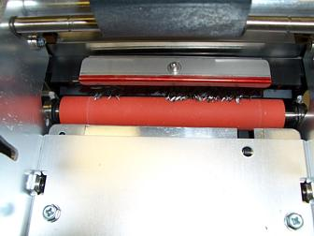

Rubber Driver Roller (Platen)

If you have any questions please contact us at 561 998 9600 ext. 170

